CS 340 README
- Project Overview and Functionality
This project delivers a full-stack web dashboard for Grazioso Salvare, an international rescue-animal training company. The dashboard allows the client to interact with and visualize the Austin Animal Center Outcomes data set in order to identify dogs that are good candidates for search-and-rescue training. It was built using the Model-View-Controller (MVC) design pattern: MongoDB holds the data (Model), Dash widgets present the data (View), and Dash callbacks coordinate the interaction between them (Controller).
The dashboard provides the following required functionality:
- A Grazioso Salvare logo and a unique identifier (the developer's name) displayed at the top of the dashboard.
- Interactive radio-button filtering options for three rescue types — Water Rescue, Mountain or Wilderness Rescue, and Disaster or Individual Tracking — plus a Reset option that returns all widgets to their unfiltered state.
- An interactive data table that retrieves records from MongoDB and updates dynamically in response to the selected filter, with native sorting, column filtering, single-row selection, and pagination.
- A breed-distribution pie chart that updates in response to the filtered data table.
A geolocation map that plots the selected animal's location and updates in response to the filtered data and the selected table row.
- Functionality Demonstration
The screenshots below were captured while running and testing the deployed dashboard. Each shows the Grazioso Salvare logo and the developer's unique identifier, along with the data table, pie chart, and geolocation map responding to the applied filter.
  - Starting State
On load, the dashboard opens with the Reset option selected and displays the complete, unfiltered Austin Animal Center data set across all three widgets.
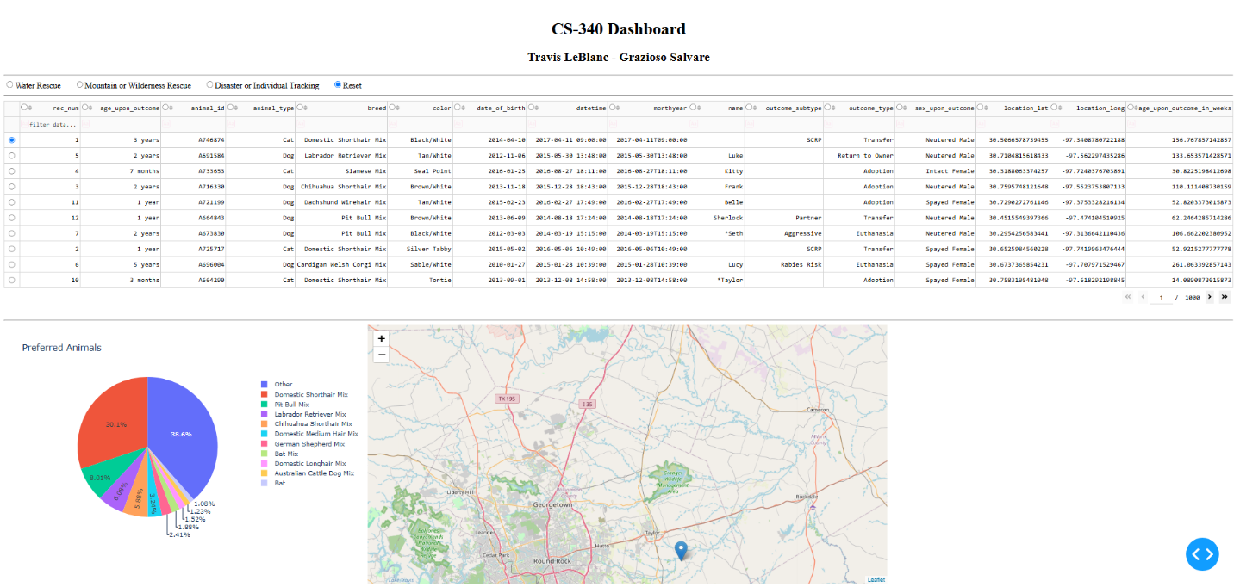
  - Water Rescue Filter
Water Rescue returns intact female dogs of the preferred water-rescue breeds (Labrador Retriever Mix, Chesapeake Bay Retriever, Newfoundland) within the target age window. The table, pie chart, and map all update accordingly.
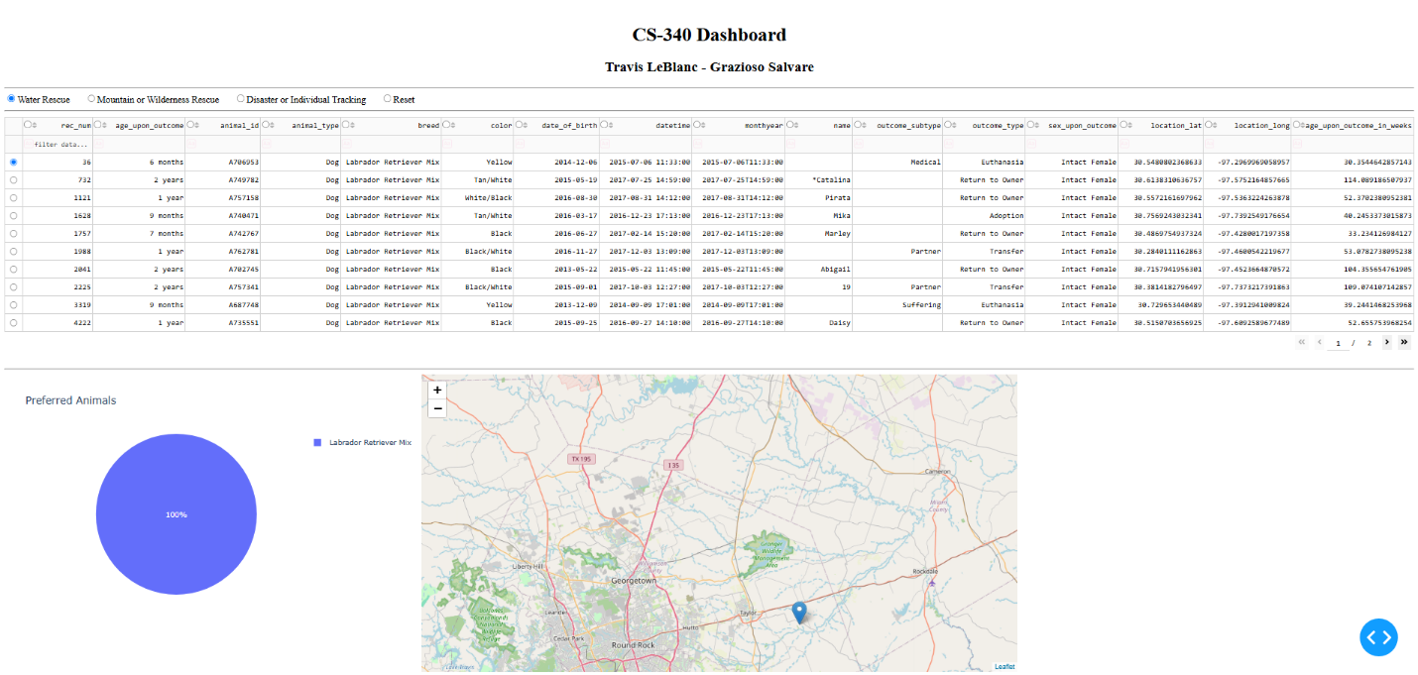

  - Mountain or Wilderness Rescue Filter
Mountain or Wilderness Rescue returns intact male dogs of the preferred breeds (German Shepherd, Alaskan Malamute, Old English Sheepdog, Siberian Husky, Rottweiler) within the target age window.
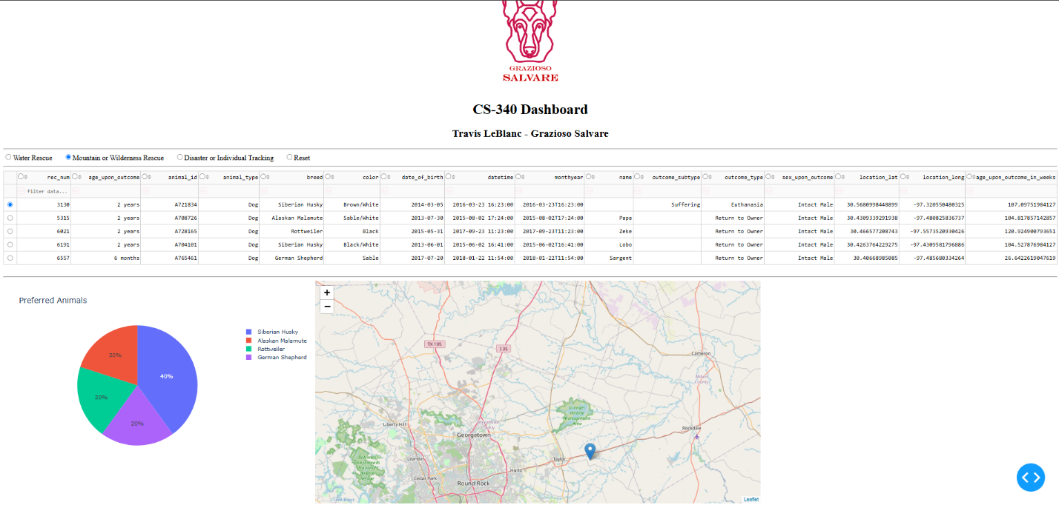
  - Disaster or Individual Tracking Filter
Disaster or Individual Tracking returns intact male dogs of the preferred breeds (Doberman Pinscher, German Shepherd, Golden Retriever, Bloodhound, Rottweiler) within the target age window.
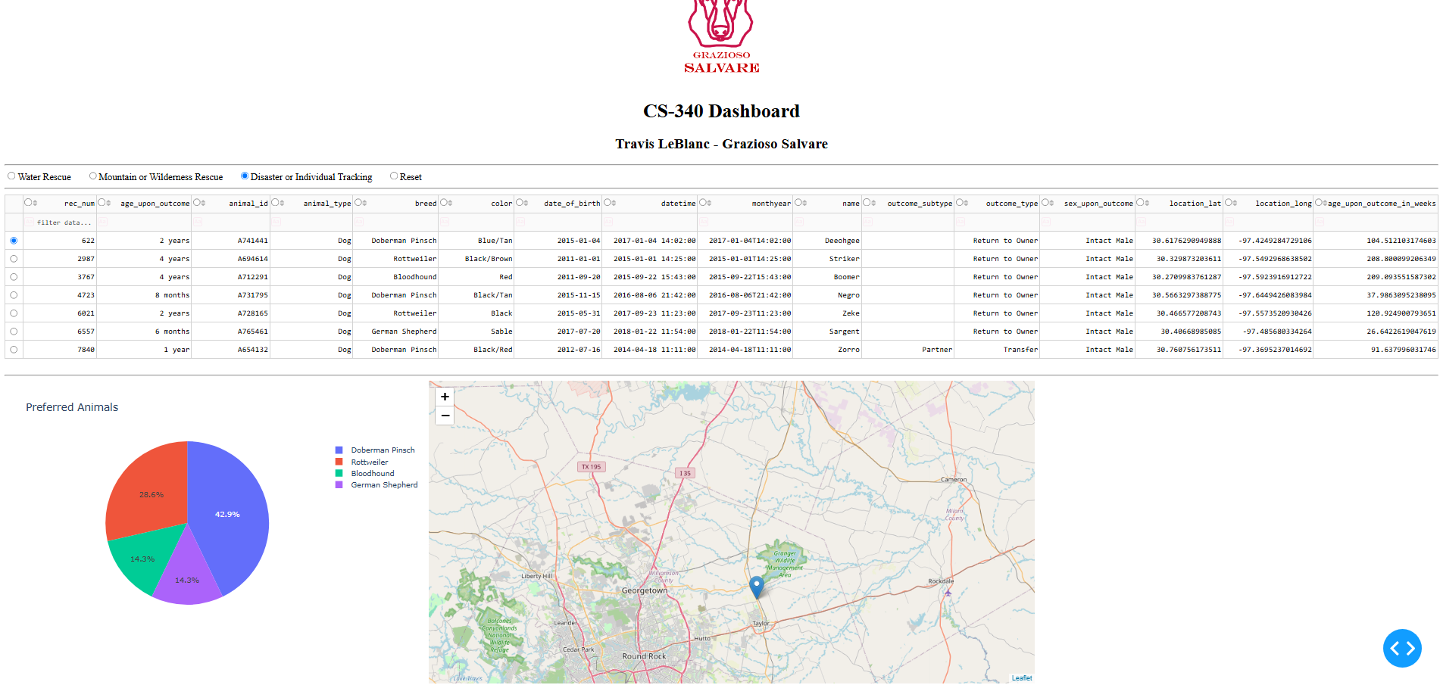
  - Reset
Selecting Reset returns every widget to its original, unfiltered state.


- Tools and Rationale
The application follows the MVC pattern, and each tool was selected for the role it plays within that structure.
Why MongoDB for the Model
MongoDB was used as the Model because it is a document-oriented NoSQL database whose data model aligns naturally with Python. Documents are stored as BSON, which maps directly to Python dictionaries, so query results returned by PyMongo arrive as a list of dictionaries that can be loaded straight into a pandas DataFrame and then into a Dash data table with no format conversion or object-relational mapping layer in between. Its flexible schema accommodates the varied fields in the Austin Animal Center data set, and its expressive query language — operators such as $in for breed lists and $gte / $lte for age ranges — made the rescue-type filters concise and readable. MongoDB also supports indexing and role-based authentication (the aacuser account), which keep the queries performant and access controlled.
Why the Dash Framework for the View and Controller
Dash, Plotly's open-source Python framework, supplies both the View and the Controller, which let the entire application be written in Python without separate HTML, CSS, or JavaScript files. The View is the declarative component layout in app.layout — the logo, the dcc.RadioItems control, the dash_table.DataTable, the Plotly Express pie chart, and the Dash Leaflet map. The Controller is the set of reactive @app.callback functions that listen for input (a radio selection or a row selection) and update the dependent widgets. This reactive, decorator-based wiring is what makes the dashboard interactive: choosing a filter triggers a MongoDB query whose result repopulates the table, which in turn drives the pie chart and the map. JupyterDash was used so the app runs directly inside the Codio Jupyter environment.
- Steps to Complete

- Reused the CRUD module. The AnimalShelter class developed in Project One (CRUD_Python_Module.py) provided create, read, update, and delete operations through PyMongo. Project Two imported this module and used its read() method for every query.
- Connected to the database. Instantiated AnimalShelter with the aacuser credentials, then ran a “retrieve all” query (read({})) to load the full data set into a pandas DataFrame, dropping the MongoDB _id field so the data table could serialize the rows.
- Built the layout (View). Added the base64-encoded Grazioso Salvare logo and a unique-identifier header, the radio-button filter control, the interactive data table (carried over from the Module Six Milestone), and a flexbox row holding the pie chart and the map side by side.
- Wrote the filter queries. Created MongoDB queries matching the Rescue Type and Preferred Dog Breeds specification — breed lists via $in, sex via an exact match, and age ranges via $gte / $lte for each of the three rescue types.
- Wired the controller callback. Connected the radio selection to the matching query so its result becomes the data table's data, converting the table from a static display into the output of the filter.
- Added the responsive charts. Built a pie-chart callback and the geolocation-map callback that both read derived_virtual_data from the table, so they refresh automatically whenever the filter changes the table contents.
- Tested and deployed. Ran the notebook in Codio, exercised each of the four filters plus Reset, confirmed every widget responded correctly, and captured the screenshots included in Section 2.

- Challenges and Resolutions
- Pie chart did not respond to the filter. The chart initially plotted the global, unfiltered DataFrame, so it never changed when a filter was applied. It was corrected to build its data from the table's derived_virtual_data, so it now reflects only the filtered rows.
- Pie chart container collapsed. Because the map had an explicit size but the chart did not, the chart's div collapsed to zero width inside the flex row and rendered blank. Assigning an explicit width to the chart and map containers let them share the row and display together.
- Unfiltered pie chart was unreadable. In the full data set, plotting every breed produced dozens of tiny one-percent slivers and an overflowing legend. Collapsing all breeds beyond the top ten into a single “Other” category produced a clean, readable chart while leaving the filtered views — which contain only a few breeds — unchanged.
- Map callback crashed on an empty selection. After a filter replaced the table data, the selected-rows list could come back empty, causing an index error when the map tried to read the first selection. Adding a guard that defaults to the first row when the selection is empty kept the map stable through every filter change.
- ObjectId serialization. MongoDB returns an _id field of type ObjectId that the Dash data table cannot serialize. Dropping the _id column from the DataFrame before passing data to the table resolved the issue, both on initial load and inside the filter callback.

- Reproducing the Project
  - Prerequisites
- A running MongoDB instance containing the aac database and animals collection, loaded with the Austin Animal Center Outcomes data set (mongoimport from the provided CSV).
- A database user (for example, aacuser) with read access to the aac database.
- Python 3 with the following packages installed: jupyter-dash, dash, dash-leaflet, plotly, pandas, pymongo.
  - Included Files
- ProjectTwoDashboard.ipynb — the dashboard source code.
- CRUD_Python_Module.py — the AnimalShelter CRUD module from Project One.
  - Reproduction Steps
    - Place ProjectTwoDashboard.ipynb, CRUD_Python_Module.py, and the logo image in the same working directory.
    - Open CRUD_Python_Module.py and confirm the MongoDB host, port, database (aac), and collection (animals) match your environment.
    - Open the notebook and confirm the username and password variables match your database user, and that image_filename matches the logo file name exactly.
    - Run the notebook cell. JupyterDash starts the server and renders the dashboard inline.
    - Use the radio buttons to apply each filter and confirm the data table, pie chart, and map update; select Reset to return to the full data set.

